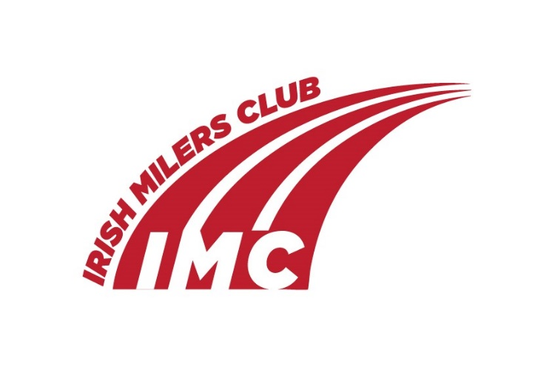

UCD- IMC Meet, UCD Track, June 10 ,2023. TIMETABLE
No Call Room - Athletes just need to be at start lines at times below

Time | Event
14.00 | Hammer
14.30 | 3k Men A
14.35 | Shot
14.43 | 200m Women A
14.49 | 200m Men B
14.55 | 200m Men A
15.05 | 3k Men B
15.18 | 400m Men B
15.24 | 400m Men A
15.30 | 400m Women A
15.36 | 800m Men G
15.43 | 800m Women B
15.50 | Mile Men C
15.58 | Mile Men B
16.06 | 800m Men F
16.13 | 800m Men E
16.23 | 100m Women B
16.29 | 100m Men B
16.35 | 100m Women A
16.41 | 100m Men A
16.51 | 1500m Women B
16.59 | 1500m Women A
17.09 | 800m Men D
17.16 | 800m Women C
17.23 | 800m Men C
17.30 | 800m Men B
17.37 | 800m Women A
17.44 | 800m Men A
17.51 | Mile Men A
18.00 | Women 3k

